Website content

Title: I wan na reset

Content:

(1).word

巨大的机器撕绞着 Huge machine tears

榨压弱小者的幸福 The happiness of pressing the weak

我为你挡下难过 I am sorry for you

因我决不放弃相信 Because I never give up believing

我们生而平等 We are born equal

self introduction

A little mad free man

(2).photos

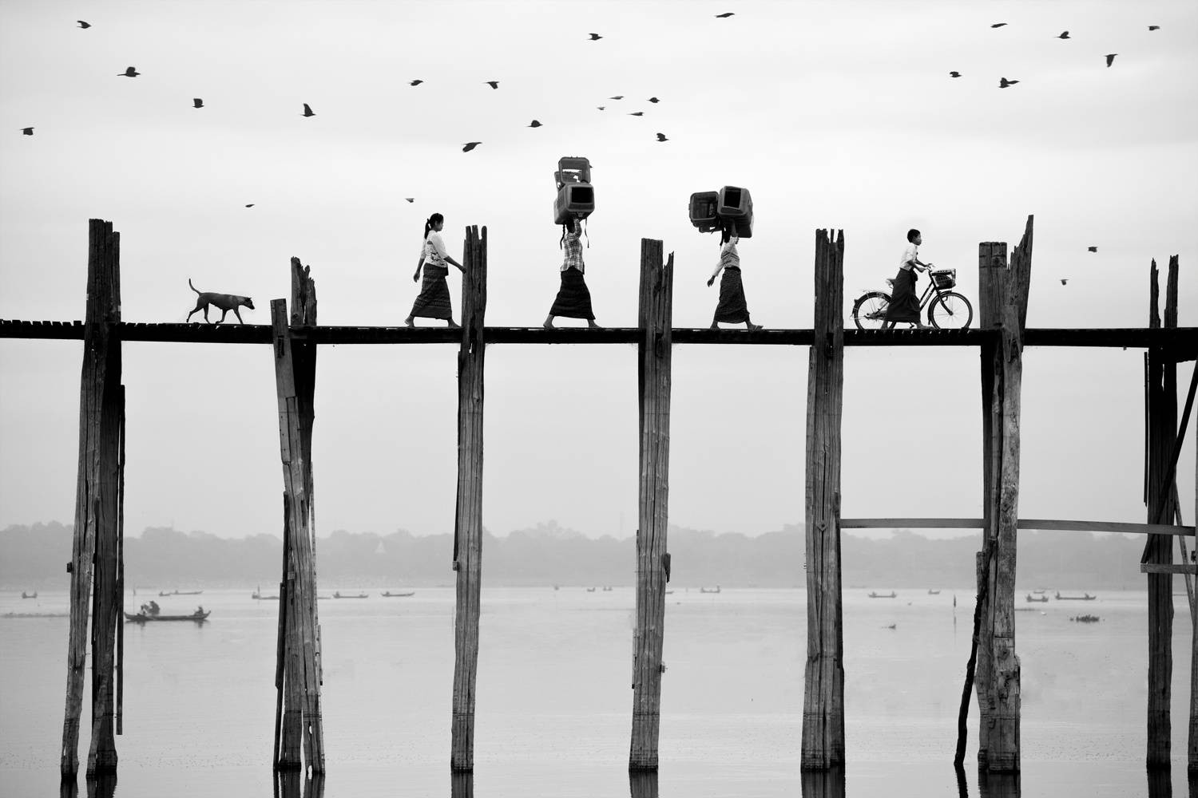

As the background of the entire site

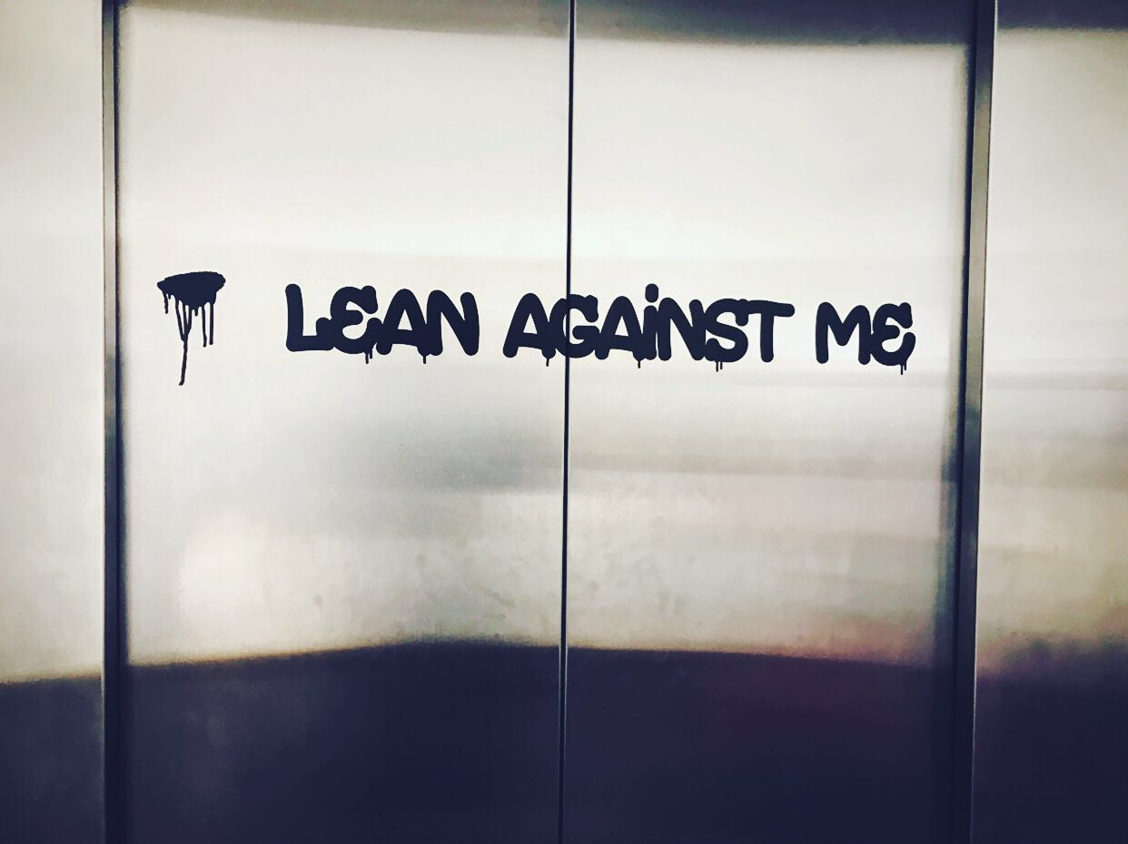

100\*50 as the ending



50\*50 as the avatar

(3).text

I may be lost. I may be lost. I may not be able to arrive anywhere. Maybe I have lost everything. Even if I struggle, I will only be able to say nothing. Maybe I just vainly put a lot of rubble in the dust. No one has placed a bet on me. Does not matter. One thing is clear: At least I have something worth waiting for.

(4).link

http://www.jorgerieraflores.com/